Microsoft Office Project Server 2007

September 2006



Table of Contents

Cover is for   
position only

Overview of Microsoft Office Project Server 2007 2

Gain Visibility and Insights 2

Enterprise Ready 3

Easier to Get Started 3

Extensible and Programmable 4

Gain Visibility and Insights 5

Manage Resources 5

Control Project Finances 5

Budget for Financial Control 6

Assign Costs to Tasks 6

Visibility Across the Entire Project Life Cycle 7

Analyze and Create Custom Reports 8

Enterprise Ready 11

Manage the Simple and the Complex 11

Improved Performance 11

Resource Management 12

Use Enhanced Timesheet Capabilities 12

Easier to Get Started 15

Access Project Information via the Web 15

Enhance Knowledge Sharing 16

Build on Existing Investments and Knowledge of Desktop Applications 17

Save Time with Templates 18

Create Your Own Templates 18

Use Predefined Templates 18

Extensible and Programmable 21

Manage the Project Server Solution 21

Fully Customizable 21

Architecture 25

Backward Compatibility, Interoperability, and Migration 27

Summary of Office Project Server 2007 Benefits 29

System Requirements 30

System Requirements for Office Project Professional 2007 30

System Requirements for Office Project Server 2007 32

System Requirements for Project Web Access 2007 34

Additional Resources 36

# Overview of Microsoft Office Project Server 2007

Microsoft® Office Project Server 2007 and its clients enable you to effectively manage projects and resources across your organization. Microsoft designed Office Project Server 2007 for organizations needing strong team coordination, standardization in managing projects and programs, and centralized resource management. Project provides a central repository of information so that organizations can analyze, manage, and report across the enterprise.

The capabilities of Office Project Server 2007 are exposed through its clients: Microsoft Office Project Professional 2007 and Microsoft Office Project Web Access, which requires a Client Access License. Office Project Professional 2007 incorporates all the features of Microsoft Office Project Standard 2007. Please refer to the Office Project Standard 2007 Solution Guide for more information. To learn more about the specifics of portfolio management, please refer to the Microsoft Office Project Portfolio Server 2007 Solution Guide.

The new version of Office Project Server 2007 delivers improvements in several areas:

* Visibility and insights
* Enterprise readiness
* Ease in getting started
* Extensibility and programmability

## Gain Visibility and Insights

Visibility means you can easily find, analyze, and report on all types of information about your projects. From one-time projects to complex programs, organizations can analyze their work and resource investments. In addition to active projects, you can now see the entire project life cycle from before initiation as Proposals to after project completion as Activity Plans.

Key improvements to deliver these capabilities include:

* **New! Budget Tracking**
* **New! Cost Resources**
* **New! Cube Building Service**
* **New! Multiple Currencies**
* **New! Activity Plans**
* **New! Proposals**
* **New! Reporting Data Service**
* **New! Resource Plans**
* **New! Visual Reports**

## Enterprise Ready

A dependable, scalable offering, an Office Project Server 2007 deployment provides a high-performance, manageable infrastructure that organizations can use to efficiently manage work from simple projects to large programs consisting of multiple projects. Key features that deliver greater enterprise readiness include:

* **New! Active Cache**
* **New! Assignment Owner**
* **New! Deliverables**
* **New! Import Project Task Lists**
* **New! Programs**
* **Enhanced! Timesheets**
* **New! Queuing Service**
* **New! Team Resource**

## Easier to Get Started

The new version enhances participation across the entire organization with richer access through familiar applications that integrate with Office Project Server 2007 to view, update, and analyze project information. This functionality promotes coordination among project teams, which improves collaboration and yields more data for analysis and reporting. For example, the integration of Office Project Server 2007 with Microsoft Windows® SharePoint® Services 3.0 enables you to centrally store, link, and share project-related issues, risks, and documents for collaborative tracking. Propagate best practices for project work with enterprise templates to improve project management process throughout your organization. A number of improved features contribute to expanding the value and use of the system in your organization.

* **Enhanced! Outlook Integration**
* **Enhanced! Project Guide**
* **Enhanced! Project Web Access**
* **Enhanced! Project Workspaces**
* **Enhanced! Templates**

## Extensible and Programmable

Office Project Server 2007 provides the flexibility to meet your needs as your business requirements evolve. You can customize and integrate Project Server data with existing systems through the new Project Server Interface (PSI) application programming interface (API) and Microsoft Visual Basic® for Applications object model changes. A redesigned architecture and new features support more users with better performance. Office Project Server 2007 reduces the burden of administration with setup improvements, while Office Project Web Access provides an improved administrative interface. Office Project Server 2007 includes many other useful new features, such as:

* **Enhanced! Administration User Interface**
* **New! Event Model**
* **New! Project Server Interface**
* **New! Project Web Access as Web Services**
* **New! Server-Side Scheduling**

# Gain Visibility and Insights

Office Project Server 2007 now covers a broader range of work and tracks a wider range of information to provide you better control of your organization’s activities, resources, and investments. This information will enable you to analyze your investments, whether they are one-time projects or complex programs and portfolios. You can use Office Project Server 2007 for reporting of information and analysis, which enables you to set realistic expectations with project teams, management, and customers.

## Manage Resources

Office Project Server 2007 helps you accurately assess needs to effectively deploy resources today and create future Resource Plans for your organization. Resource Plans provide information about high-level resource allocation when detailed resource assignments do not exist—for example, in proposed and anticipated projects, task-only projects, and for projects where assignments do not accurately reflect resource distribution. These plans help ensure you have the right people on your high-priority projects for optimal delivery, and have hired appropriately skilled resources according to the demands of your projects.

## Control Project Finances

By defining budgets for projects or programs, users gain better financial reporting and analysis, helping align work with corporate objectives. Project further supports financial control by introducing a new “Cost” resource type as well as predefining a number of new project accounting fields.

Also, with the Multiple Currencies feature, users can now set the rates for resources in different currencies and establish a table of exchange rate data to generate reports in a single currency.

### Budget for Financial Control

The Budget field enables Office Project Server 2007 to support the method with which many organizations allocate their budgets by specifying the amount of resources each project or program should use. A budget may be specified either as monies (for example, dollar amounts for labor, materials, or other cost types), as work (full-time equivalents), or as materials. This feature enables display of the variances between the budget with the actual roll-up numbers (work, cost, actual work, and actual cost) coming from the detailed plan.

### Assign Costs to Tasks

In Microsoft Office Project 2003, there were two types of resources: Work and Material. In Microsoft Office Project 2007, you gain a new type of resource: Cost. For each task, you can now assign multiple arbitrary costs (not based on work time) and use custom fields to specify the cost type or financial code. Cost Resources is the resource type for fixed costs assignable to a task. With Cost Resources, you can more accurately monitor project financials and keep your project in sync with data in your accounting systems by tying costs to account codes and rolling up costs against budgets. And, the costs are not tied to the work contours, so changing the percent complete or end date of the task will not affect Cost Resources.

**Figure 1: Creating a Cost Resource**

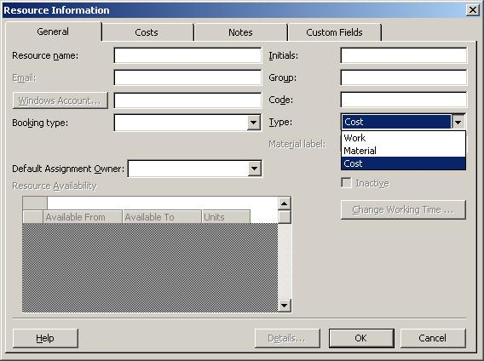

## Visibility Across the Entire Project Life Cycle

Managing work effectively requires covering the whole project life cycle—from initiation with Proposals to after project completion with Activity Plans for ongoing maintenance. Proposals now enable project initiation on the Web in Office Project Web Access. Creating Proposals enables the use of business processes to track potential projects as well as capitalize on Project functionality to perform what-if analysis prior to approval. Further, storing proposal data along with project data generates the content for better portfolio decision-making.

Using Resource Plans in conjunction with Proposals will provide a more accurate view for forecasting required resources and staff training or hiring. Resource Plans provide information about future high-level resource allocation when detailed resource assignments do not yet exist.

Project Web Access also supports management of Activity Plans, which can be used to manage the operations work that often follows completion of a project. So now you can track the full project life cycle. As a general capability, Activity Plans support the creation of simple projects in Project Web Access, which improves total work reporting.

Users can see all types of work in the Project Web Access Project Center, which provides a single view of all proposals, projects, programs, and operations work for basic reporting and analysis.

**Figure 2: Proposal entry**

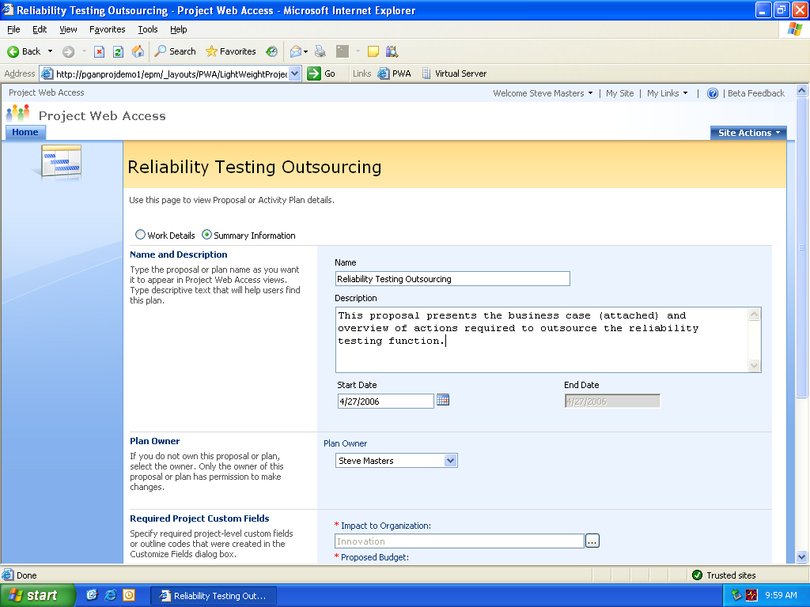

## Analyze and Create Custom Reports

One of the key uses of Office Project Server 2007 is for communication, which necessitates analytical tools and professional reports.

Easily present information in various formats according to the needs of stakeholders. You can format and print one-page schedules or other reports. Smoothly export project-related data into Microsoft Office Word for formal documents, Microsoft Office Excel® for custom charts or spreadsheets, Microsoft Office PowerPoint® for crisp presentations, or Microsoft Office Visio® for diagrams. In addition to static reports, you can generate dynamic PivotTable® reports using Office Excel and Microsoft Office Visio Professional to produce charts, graphs, and diagrams based on Project data by means of the Visual Reports feature. You can more easily define custom report templates and share them with other Project users. These reports include a data cube for drill-downs and pivots.

To gain insights by performing custom analytics without requiring a system or database administrator, users can access the Cube Building Service(CBS) via a flexible, graphical user interface to build portfolio analyzer cubes with more data options. Users can also include custom fields in the cube. The CBS consumes metadata and data generated by the Reporting Data Service (RDS) from the Reporting database to build cubes for user reporting.

To deliver these data for reports, extract the data from the Office Project Server 2007 Publish, Working, and Version databases with RDS. The RDS transforms the data into a format suitable for user reporting and Microsoft SQL Server™ Analysis Services cube building, and loads it into the Reporting database.

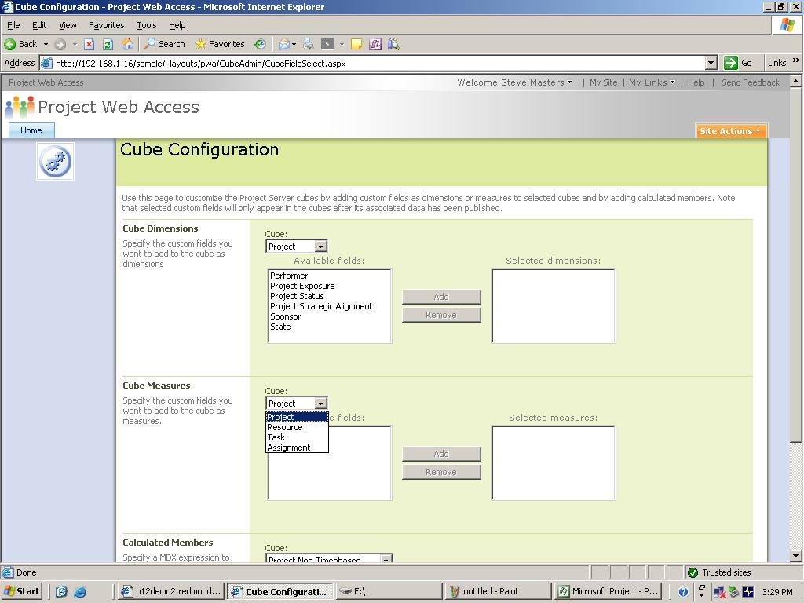

**Figure 3: Cube Building Service dialog box**

Project Server Scenario: Implementing Project Server to manage growing businesses

A team of Fabrikam International managers sits in a conference room tossing out ideas for next year’s operations. To stay competitive, their firm needs to update its existing product lines and develop several new product concepts. These ideas quickly coalesce into a set of proposals, which are entered directly into Project Web Access. To accurately reflect capacity, Resource Plans are added. The management team reviews the proposals, promotes them to full projects, and grants budgets for those that can also pass through the governance evaluation process in Office Project Portfolio Server 2007 by using the Project Gateway integration.

The individual managers can then run their projects. This involves tracking the finances based on the time accrued by resources as well as adding fixed cost resources to tasks. On a monthly basis, each manager can report back to the others by distributing files that use common visual reports based on an Excel template or data pertinent to their specific project as generated through the Cube Building Service. This way everyone stays on the same page regarding project status.

# Enterprise Ready

Office Project Server 2007 deployments can scale to support all work in distributed organizations, delivering a dependable solution that adapts in terms of both number of users and content with large programs. This flexible infrastructure provides high performance and manageability.

## Manage the Simple and the Complex

When you have a one-off project, you can use Windows SharePoint Services in conjunction with an Office Project Server 2007 deployment. Windows SharePoint Services 3.0 includes a new task list for projects. Project Web Access includes the ability to import Project Task Lists as projects. This process captures work investments and time commitments that would otherwise not have been tracked in Office Project Server 2007.

At the high end, Programsprovides for easy management of complex work that spans multiple subprojects. This means you can now generate key performance indicators and analysis at the program level rather than just the project level. To better display the cross-project dependencies within a Program, there are Deliverables. Each project manager can publish Deliverables as a SharePoint list of committed dates. Other project managers can view this list and create links from their project or tasks.

## Improved Performance

As the use of Office Project Server 2007 expands throughout an entire organization, the deployment must continue to deliver great performance for the users. In addition to enhancements to the underlying architecture, several new features accelerate response times.

TheActive Cache provides more data on demand for faster open, save, publish, and other client/server communications. This feature copies files, enterprise resource pools, enterprise global templates, and other relevant information to the user’s computer for faster access. This functionality works across wide area networks and firewalls—and delivers a smoothly integrated online and offline experience.

Users gain greater resiliency and use of server resources with the Queuing Service. The server-side queues work requests pending server availability. This capability enables users to continue working rather than waiting on the server to complete an action. For example, tens of thousands of users can submit their timesheets and shut down rather than waiting for the server to complete processing their submissions.

## Resource Management

When scheduling an organization’s work, managing resources wisely helps ensure capacity and capabilities align with current and future needs. Office Project Server 2007 adds several new features to expand its resource management capabilities.

The Assignment Owner feature enables individuals other than the assigned resource to provide status updates on an assignment. The Assignment Owner feature also enables tracking of the use of materials (nonhuman resources) or staff that does not use Office Project Server 2007 themselves. Assignments can also be changed from the current assignment owner to a new individual as necessary.

Team Resources enables work to be assigned to an entire team rather than an individual resource. Any member of the team can accept the assignment and report time against it. A Team Resource displays availability based on the team’s aggregate capacity.

## Use Enhanced Timesheet Capabilities

Planning projects relies on knowing which resources are available and which are already scheduled with work. Timesheets provide the basis for this information in Project, but they also extend well beyond the basics to serve as input for financial systems and analyzing progress.

Users can report how they spend their time on project and non-project activities by entering their hours and progress against project tasks, summary tasks, or non-project administrative tasks. For better integration into other timesheet and payment applications, Project includes many predefined project accounting codes such as cost codes. Full auditing will be available and, if enabled, an audit log entry will be created for all changes made when the timesheet is saved or submitted. Timesheets also support billable/non-billable fiscal periods and are 100 percent HTML-based. Project managers can approve or reject a timesheet independently from project status updates. Timesheets will track actual time worked, which can be protected through auditing. Additionally, managers can lock tasks and projects against further time tracking. Timesheets in Office Project Server 2007 offer users a much broader set of capabilities.

**Figure 4: New timesheet capabilities**

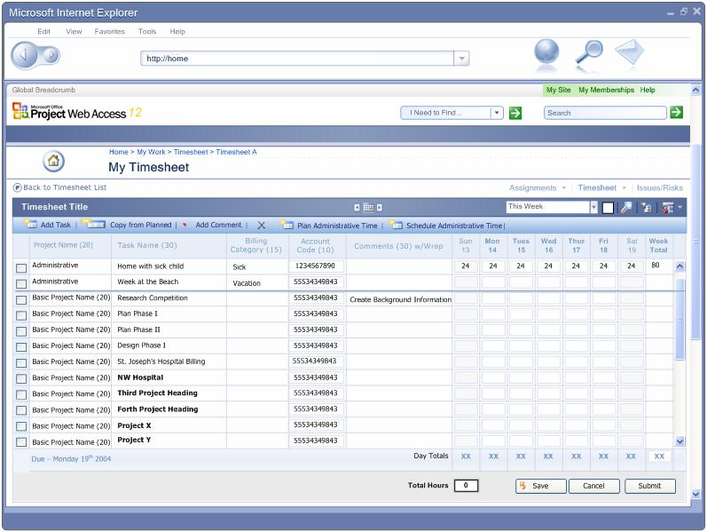

Project Server Scenario: Supporting Enterprise Activities

The vice president of operations creates a program to retool all of the firm’s manufacturing plants. The program has separate projects for each existing product line and placeholders for new products. Managers on the vice president’s team use the firm’s manufacturing line conversion template as the basis for quickly creating each project.

As the managers add specific details beyond the projects’ initial template and resource plan, they assign specific resources to tasks. But in some cases, instead of individuals, they assign tasks to team resources, which enables team members to allocate the work themselves.

The managers can start some of their work but are often blocked by dependencies on the product development team’s deliverables. These cross-project dependencies appear in a single SharePoint list of Deliverables, so the vice president can easily hold discussions with other senior managers in product development and manage expectations of executives if there are schedule slips.

Project managers often travel between manufacturing plant locations to verify progress and learn local best practices. While on the road, managers can work offline, taking advantage of the Active Cache.

The teams of thousands of workers in the manufacturing plants can all submit their timesheets concurrently and then quickly shut down as the Server-Side Queue holds their submissions for processing rather than having the workers wait. The project managers running the various components of the program can then review and approve the timesheets.

The vice president of operations can analyze and report across the entire program and its subprojects to keep other executives informed and manage issues as they arise.

# Easier to Get Started

Office Project Server 2007 enables enterprise-wide adoption by sharing reports, coordinating on the Web, and integrating with other familiar applications such as Microsoft Office Outlook® and Excel. This functionality enables you to set expectations and communicate effectively with project teams, management, and customers. Office Project Server 2007 itself is localized in 23 languages, enabled in 13 other languages and for Unicode, and supports the Multilingual User Interface Pack.

## Access Project Information via the Web

Let partners, executives, and team members view and interact with Office Project Server 2007 through Office Project Web Access. With just a Web browser, users can gain access to content and functions based on their role and authorization. You can also integrate Project Server data and functions as Web Parts into a dashboard view with other information for a complete view of your business.

**Figure 5: The Project Center in Project Web Access**

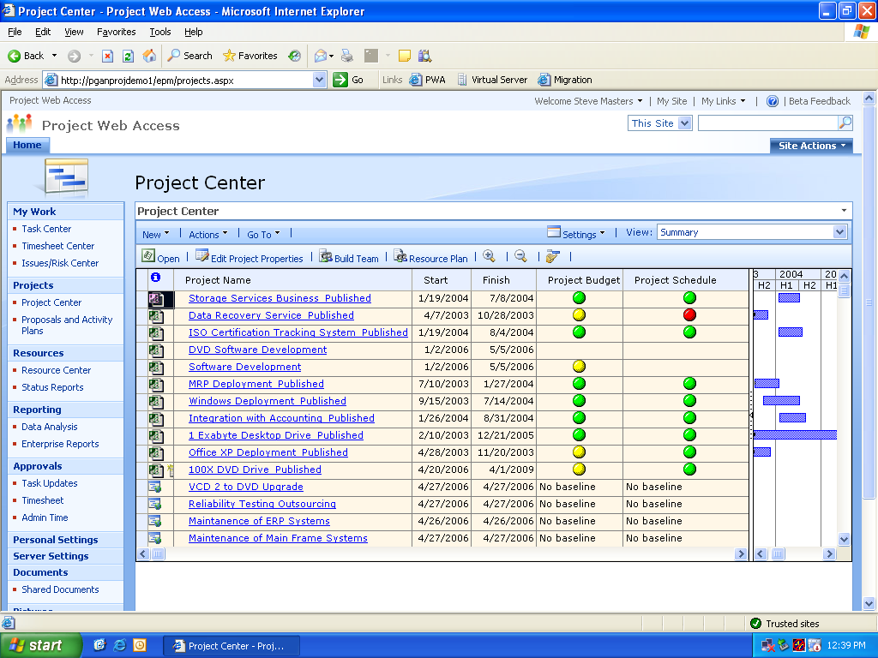

## Enhance Knowledge Sharing

Integration of Office Project Server 2007 and Windows SharePoint Services 3.0 provides a rich collaboration platform that enables teams to centrally manage and track project-related documents, issues, and risks.

Centralized document management helps users to improve the quality of project deliverables. With the Microsoft Project Task List Import template, you can build a basic task list in Excel. The Microsoft Project Plan Import Export template enables you to create the task list, add resources, and make assignments. This template can be imported into Office Project Server 2007 and exported back to Excel for revising.

Quickly master the project management process with the Project Guide, a step-by-stepinteractive aid that helps you set up projects, manage tasks and resources, track schedules, and report project information. The Project Guide, which can be turned on or off as needed, helps you learn, explore, and discover available features while quickly navigating through the project management process. With the provided instructions and wizards, you can quickly complete activities, such as defining your project, entering [tasks](javascript:AppendPopup(this,'pjdefTask_2')), assigning resources, and reporting project information to stakeholders and team members. You can also customize data fields and analytics for information specific to your projects. You can even create custom Project Guides that can be used to maintain consistency or deploy a specific project management methodology within your corporation.

## Build on Existing Investments and Knowledge of Desktop Applications

With Outlook integration, team members can view and report progress on tasks—right from their Outlook calendar or To-Do list. Team members can view project assignments and easily keep track of project tasks alongside other Outlook appointments and tasks. From Outlook, users can provide project managers with timely updates for accurate reporting. In addition, users can automatically send updates or receive notification through any SMTP e-mail system. Now, more people can participate in project management without learning a new application.

**Figure 6: Outlook integration via Project Web Access**

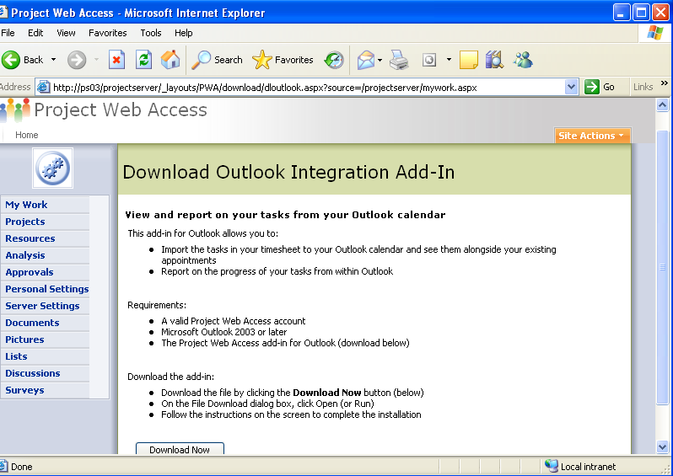

## Save Time with Templates

Project provides a wide range of predefined templates to help speed your project management process by establishing repeatable processes and capturing best practices.

### Create Your Own Templates

Save time and maximize your expertise by creating your own custom templates. This enables you to reuse an existing project as the basis for future projects. A template can capture task and resource information, formatting, macros, and other project-specific settings. Templates give you a quick start by automatically populating a new project with generic information that you can tailor to your specific needs. You can e-mail local templates to others users to share best practices for your specific functional area or industry. You can publish the templates for your whole organization as an Enterprise Template. Enterprise Templates create consistency, which enables roll-up and reporting across projects and programs.

### Use Predefined Templates

When creating a new project, you can build from a blank slate or choose templates created within your firm, provided out-of-the-box from the Project installation, or made available for download from Microsoft Office Online. Out-of-the-box templates cover a range of industries, functional areas, and business problems. These templates, ranging from Commercial Construction to New Product Development, are designed to fulfill a specific objective that meets your industry and project management needs. (See Figure 7.) Other templates help with specific project management methodologies such as agile development with Scrum or quality management with Six Sigma.

Microsoft also provides two templates that you can use in Office Excel 2003 to start a new project, create a task list, and include resources. These files can then be imported into Project. These templates automatically map fields and information directly into their Project equivalent.

**Figure 7: Create a new project based on predefined project templates.**

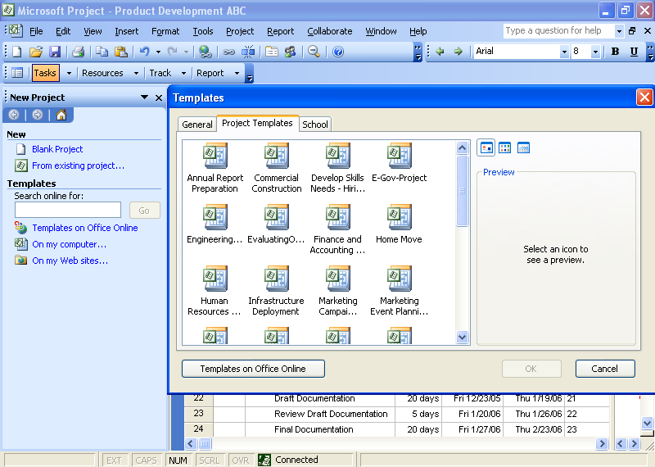

Project Server Scenario: Accelerating Adoption and Value

Currently, Fabrikam International is working on a large-scale project with two project managers to develop a complex new product offering. The project is expected to take two years to complete. Both project managers worked together to create and promote the proposal for a project to which they added all the details required for operational control and reporting of progress.

The project managers did not start from a blank slate. They made use of the approved enterprise template and Product Guide for new products. The vice president of product development had analysts create the best practice template and a custom Project Guide. These tools helped the managers save time and create consistency for reporting and decision-making.

The managers also needed several levels of communication to involve team members and keep executives informed. To provide team collaboration, the project managers created user accounts on Office Project Server 2007 for their team members by syncing with Active Directory® directory service. They also selected the option for e-mail notification, which sends messages indicating the assignment of tasks to team members.

The team working on the project also installed the COM add-in for Outlook integration so they can import Project assignments to their Calendar and To-Do lists. This enables the people working on these projects to report time and progress directly from Outlook.

For overall time and status reporting, their accounts on Project Server grant the project managers access to the complete timesheet function in Project Web Access. Project Web Access offers a range of other collaboration functions for status reporting, sharing issues and risks, managing documents, and more, because Project Web Access is built on Windows SharePoint Services.

As the project proceeds, the managers can monitor resource use levels, approve timesheets, and measure task progress. They can adjust resource allocations and accommodate scope changes while working to keep on the original schedule.

The project managers also needed to keep the project’s sponsors and the rest of the management team informed of progress and to manage their customers’ expectations for delivery. To communicate their timeline, key deliverables, and finances, the managers created accounts for the project sponsors in Project Server. The sponsors can use the Project Web Access Project Center to analyze the project’s progress. The project managers can also use the Visual Reports function in Project Professional to create dynamic report templates in Excel and Visio Professional to communicate monthly status to the broader Fabrikam executive committee.

# Extensible and Programmable

Office Project Server 2007 provides enterprise class capabilities for performance and scalability as well as a better foundation for extending and customizing Project as a platform for managing your organization’s work. Office Project Server 2007 offers workflow to integrate business processes with project work. Your existing software investments will gain better synergy via the Office Project Server 2007 improved API. The new version more readily exposes administrative functionality through Project Web Access.

## Manage the Project Server Solution

To save time and reduce the learning curve for Office Project Server 2007 administrators, the new version consolidates security and other management functions on a single, refactored Web service called Server Settings. Project Server includes a connector that facilitates synchronization from Active Directory to Project Server. This imports Active Directory users to populate the Enterprise Resource Pool and Active Directory security groups, distribution groups, and organization units to Project Server security groups. This means you benefit by not having to implement and manage specific directory services.

## Fully Customizable

All Project Server clients and components for integration (Project Web Access, Project Professional, and third-party applications) now interact with Office Project Server 2007 through the Project Server Interface (PSI). The PSI, our application programming interface, is documented in the software development kit, which is posted to MSDN® for free download.

**Figure 8: Programming with the PSI**

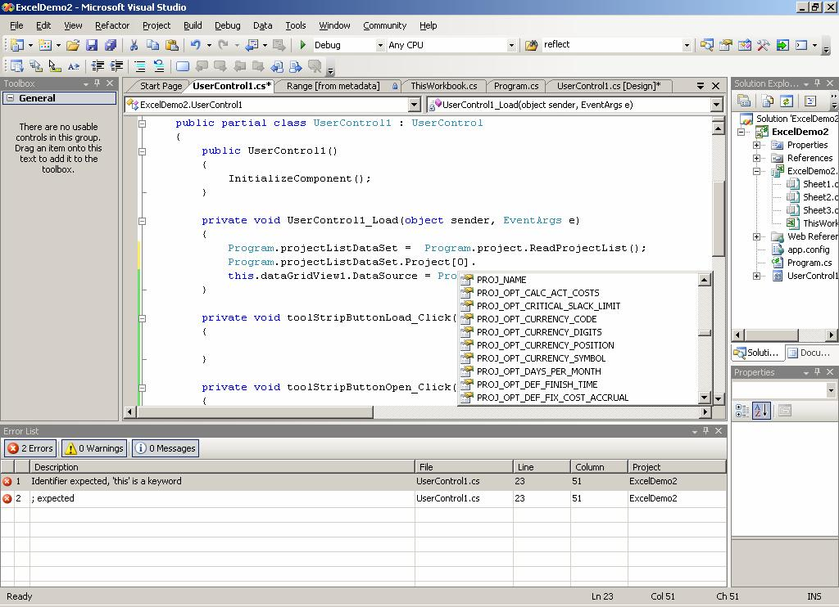

The PSI, along with the Project ServerEvent Model, exposes the functionality and data that client applications need to integrate with Office Project Server 2007. The server-side Event Model can trigger workflow for business processes defined with Windows Workflow Foundation.

**Figure 9: Event Handler to initiate workflow**

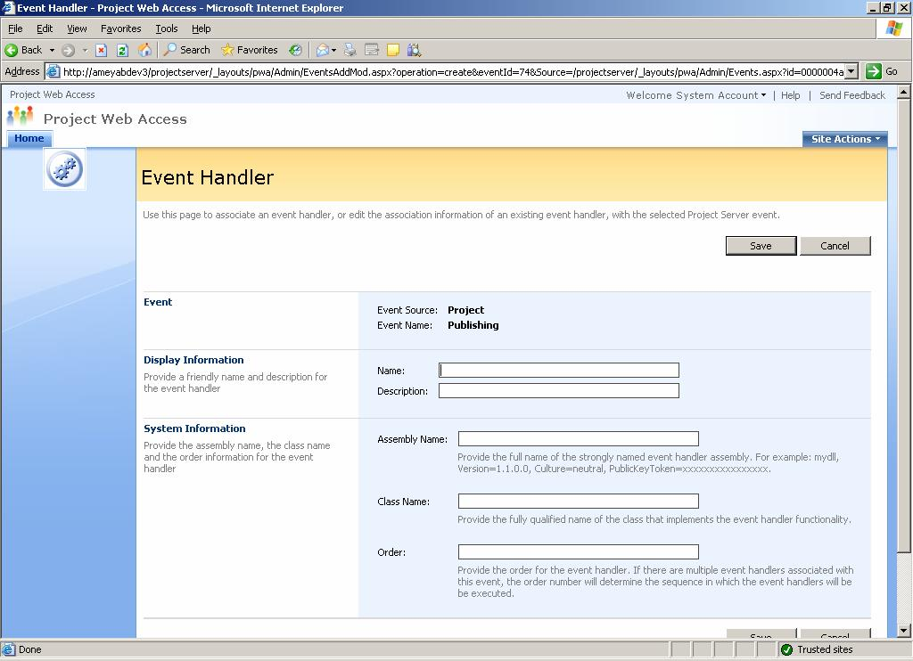

The new Server-Side Scheduling moves the scheduling engine from Project Professional to the Project Server. This enables you to create a front end without relying on Project Professional for schedule calculations. Now if a third party builds a front end, they no longer have to have Winproj.exe on each client because the server contains the scheduling engine. This reduces license needs from Professional to a Client Access License.

Additionally, you have greater ability to customize Project Web Access or reuse its capabilities because it is built on Windows SharePoint Services 3.0 and exposes all functions as Web services. This also means you can flexibly format the Project Web Access interface with all of the tools in Windows SharePoint Services 3.0.

The administrative interface has been redesigned for better access and to expose new functions.

Project Server Scenario: Extending the Platform to Suit Special Needs

Fabrikam International is undertaking a large-scale initiative with business partners. This initiative requires integration to back-end systems, custom reports, and workflow. The internal IT group has been training developers with the new API in Project (the Project Server Interface), the .NET Framework 3.0, and the free tool Windows Workflow Foundation. They have the skills in-house to customize their Office Project Server deployment.

The extensible platform of Project enables the IT group to create the necessary custom integration to their timesheet system as well as using the free ERP Connector to establish integration between their EPM Solution and their SAP system.

Fabrikam can develop custom applications to include an extranet portal where suppliers can view what they have committed to deliver, custom workflow to support an approval process for changes to requirements, and a program dashboard in Microsoft Office Business Scorecard Manager that the executive committee can use to track progress and issues within projects and programs.

# Architecture

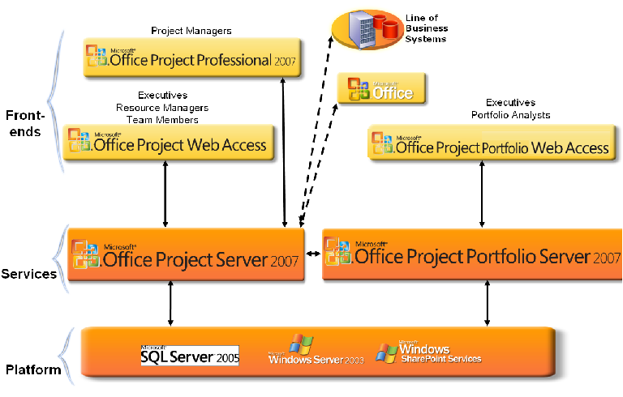

**Figure 10: Deployment components**

The three-tiered architecture consists of:

* A front end: Project Web Access, the thin Microsoft Internet Explorer® client, or Project Professional, the Win32 client. In addition to the dedicated Project clients, other Microsoft Office applications can also serve as front ends due to integration. Microsoft Visual Studio® and Microsoft Dynamics™ (formerly Microsoft Business Solutions) both offer connectors to Project Server. Microsoft offers an ERP Connector and a Siebel Connector as examples of how to integrate with line-of-business systems.
* A middle tier: Project Server delivers the business logic and services. Project Server can be accessed programmatically with the Project Server Interface API as described in our software development kit (SDK) that is posted on MSDN. Furthermore, to form the full EPM Solution you can also use the bi-directional Project Gateway to add Office Project Portfolio Server 2007.
* A back end: Microsoft SQL Server, Windows Server®, and Windows SharePoint Services.

For further details, please refer to the system requirements section.

# Backward Compatibility, Interoperability, and Migration

Office Project Professional 2007 can open files created in previous versions of Project. You can save project plans in prior formats, such as Project 2003, Project 2002, and Project 2000 file formats. Any features that do not map to prior file formats will be discarded when the project is saved in that file format.

Office Project Professional 2007 saves to file formats including XML, CSV (Comma Separated Values), Text (Tab delimited), Microsoft Excel workbook, Microsoft Excel PivotTable, Web page, and Office Project 2003. It does not support saves to ODBC data sources or .mdb files. Project 2000 and later versions no longer save project plans to the .mpx format.

Office Project Professional 2007 cannot connect to or interoperate with earlier versions of Project Server. Similarly, Office Project Server 2007 does not interoperate with prior versions of Project Professional. Office Project Server 2007 does provide a migration tool that enables certain data (including project and other Project Web Access data such as security settings or Project Web Access views) in Project Server 2003 to be migrated over.

You can continue to use the same infrastructure (Windows Server 2003 and SQL Server 2000) detailed in system requirements to support Office Project Server 2007. However, Project Web Access now requires Windows SharePoint Services 3.0 and some functions require the .NET Framework 2.0.

Office Project Portfolio Server 2007 includes a bi-directional gateway to integrate with Office Project Server 2007. Specific points of interoperability include:

* Create, prioritize, optimize, and select project portfolios within Project Portfolio Server and automatically export the selected projects to Project Server, dynamically notifying the project manager that the project has been created.
* Export derived valuation attributes from Project Portfolio Server to Project Server (for example, NPV, IRR, ROI, Strategic Value, Risk Assessment scores, and others).
* Manually map fields between Project Portfolio Server and Project Server and create mapping templates for automatic data transfer.
* Set automatic synchronization events between Project Portfolio Server and Project Server to help ensure the project data remains current in both environments; or manually refresh the data as required.
* Strengthen existing project management processes with the methodologies and analytics included within Project Portfolio Server (for example, Impact Assessments, Constraint Analysis, Efficient Frontier Analysis, and Sensitivity Analysis).

This integration enables organizations to identify, prioritize, and select the right investments, to help ensure alignment with strategic objectives, and to successfully execute the resulting projects to achieve the forecasted benefits.

# Summary of Office Project Server 2007 Benefits

Office Project Server 2007 and its clients address the needs of key stakeholders to:

* Gain visibility to align work with strategic business objectives and insights to make decisions from the strategic portfolio level to tactical operations.
* Efficiently manage finances and resources for projects and programs from initiation and throughout their entire life cycle.
* Collaborate on and communicate the status of work and investments.
* Take advantage of integration with Microsoft Office system programs and other existing software infrastructure.
* Customize the Project Server deployment to meet your organization’s unique needs.
* Integrate with Office Project Portfolio Server 2007 to form the complete Microsoft Office Enterprise Project Management Solution.

To evaluate Office Project Server for your organization, please contact your account manager for a hosted trial.

# System Requirements

An installation of Office Project Server 2007 consists of Office Project Server 2007, Office Project Professional 2007, and Office Project Web Access. Each of these products has its own system requirements.

## System Requirements for Office Project Professional 2007

To use Project Professional 2007, you need:

| **Component** | **Requirement** |
| --- | --- |
| **Computer and processor** | 700 MHz processor or faster |
| **Memory** | 512 MB of RAM or more |
| **Hard disk** | 1.5 GB of available hard disk space for installation |
| **Drive** | CD-ROM or DVD drive |
| **Display** | Minimum 800 x 600; 1,024 x 768 or higher-resolution monitor recommended |
| **Operating system** | Microsoft Windows XP SP2 or later, Microsoft Windows XP Tablet Edition 2005 Service Pack SP2 or later, Microsoft Windows Server 2003 SP1 or later, Microsoft Windows Vista™ (or later) required |
| **Browser** | Microsoft Internet Explorer 6.0 with service packs (or later); 32-bit browser version is supported |
| **Network connection** | 2 megabits per second (Mbps) or faster is required to connect to Office Project Server 2007 |
| **Additional components** | * Office Project Server 2007 is required for enterprise project and resource management capabilities * Microsoft Office Project Web Access with Office Project Professional 2007 and Microsoft Office Outlook 2003 SP2 or later required for importing tasks to the Outlook calendar or tasks list * Windows Server System™ 2.0 or later is required to open documents from or save to a Windows Server System documents site * Windows Server System 3.0 (gets installed as part of Microsoft Office Project Server 2007) is required for publishing projects, Windows Workflow Foundation, and Project Tasks List * Microsoft Office Excel XP SP2 or later is required to export to Excel * Word, PowerPoint, and/ or Visio XP SP2 or later required to use Copy Picture to Office * Outlook 2003 SP2 or later is required to use the Import Outlook Tasks feature * Microsoft .NET Framework 2.0 is required for the Resource Substitution Wizard   To use Visual Reports, the following is required:   * Office Excel 2003 SP2 or later * Office Visio Professional 2007 |

# System Requirements for Office Project Server 2007

Office Project Server 2007 processor, RAM, and hard disk requirements are highly dependent on the number of services installed on the computer and the load on the server.

Minimum requirements assume one server where all Project Server components and supporting technologies (such as Microsoft SQL Server or Microsoft Windows Server System) are installed.

To use Office Project Server 2007, you need:

| **Component** | **Requirement** |
| --- | --- |
| **Operating system** | Microsoft Windows Server 2003 SP1 or later (32-bit or x64) |
| **Stand-alone installation** | Server with a processor speed of at least 2.5 GHz; RAM capacity minimum of 1 GB, 2 GB recommended; Microsoft SQL Server 2005 SP1 Express needs to be installed on the same server; disk space: 2 GB for installation |
| **Single box installation** | * Server with a processor speed of at least 2.5 GHz; RAM capacity minimum of 1 GB, 2 GB recommended; disk space: 1 GB for installation * Microsoft SQL Server 2000 SP3a (or later) or SQL Server 2005 SP1 with a processor speed of at least 2.5 GHz, minimum 2 GB of RAM |
| **Farm deployment** | * Web server with a processor speed of at least 2.5 GHz, minimum 2 GB of RAM; disk space: 500 MB for installation * Application server with a processor speed of at least 2.5 GHz, minimum 2 GB of RAM; disk space: 500 MB for installation * Microsoft SQL Server 2000 SP3a (or later) or SQL Server 2005 SP1 with a processor speed of at least 2.5 GHz, minimum 2 GB of RAM |
| **Drive** | DVD drive |
| **Display** | Minimum 800 x 600; 1,024 x 768 or higher-resolution monitor recommended |
| **Browser** | Microsoft Internet Explorer 6.0 with service packs (or later); 32-bit browser version is supported |
| **Network Connection** | 100 megabits per second (Mbps) connection speed is required to use Project Server functionality |
| **Other requirements** | Microsoft .NET Framework 3.0; Internet Information Services (IIS) 6.0; ASP.NET 2.0; ASP.NET Web services extensions must be enabled in IIS |
| **Additional components** | Office Project Server 2007 processor, RAM, and hard disk requirements are highly dependent on the number of services installed on the computer and the load on the server.   * Microsoft SQL Server Analysis Services 2005 SP1 or later (included with Microsoft SQL Server) is required for Data Analysis (OLAP Reporting) * Internet Simple Mail Transfer Protocol/Post Office Protocol 3 (SMTP/POP3), Internet Message Access Protocol 4 (IMAP4), or MAPI-compliant messaging software is required for e-mail notifications |

# System Requirements for Project Web Access 2007

Microsoft Office Project Web Access is a Web portal used to access the information stored in Microsoft Office Project Server 2007. Using Project Web Access requires a Project Server 2007 Client Access License (CAL).

To use Project Web Access, you need:

| **Component** | **Requirement** |
| --- | --- |
| **Computer and processor** | 700 MHz processor or faster |
| **Memory** | 128 MB of RAM or more recommended (additional memory may be required depending on operating system requirements) |
| **Hard disk** | 5 MB of available hard disk space per workstation |
| **Operating system** | Windows 2000 SP4 or later, Windows XP SP2 or later, Windows XP Tablet Edition SP1 or later, Windows Vista (or later) required |
| **Display** | Minimum 800 x 600; 1,024 x 768 or higher-resolution monitor recommended |
| **Applications** | For Data Analysis and Resource Availability views, the following are required:   |  |  | | --- | --- | | • | For read-only mode, Microsoft Office Web Components (OWC) 2003 running on Windows 2000 with Service Pack 3 or later. | | • | In addition, to use Office Web Components in full interactive mode to create Data Analysis views, a valid end-user license for a Microsoft Office 2003 Edition, Office Project Professional 2007, or any Microsoft Office system program is needed. |   32 MB of hard disk space are required for the OWC installation per workstation |
| **Browser** | Microsoft Internet Explorer 6.0 with service packs (or later); 32-bit browser version is supported |
| **Network connection** | 256 KB or faster connection |
| **Other** | * Microsoft Office Outlook 2003 SP2 or later is required for importing tasks to the Outlook calendar or tasks list * Internet SMTP/POP3, IMAP4, or MAPI-compliant messaging software is required for e-mail notifications. |

# Additional Resources

To learn more about Microsoft Office Project Server 2007, please refer to the following list of related links for additional resources and information.

* Project Home Page  
  <http://www.microsoft.com/office/project/>
* MPA, the official industry association for Microsoft Office Project   
  <http://www.mympa.org>
* Microsoft Office Project Communities  
  <http://www.microsoft.com/technet/community/en-us/project/default.mspx>
* Microsoft Office Project Developer Center  
  <http://msdn.microsoft.com/office/program/project/>
* Microsoft Office Project TechNet  
  <http://www.microsoft.com/technet/prodtechnol/project/default.mspx>
* Microsoft Office Project Support Information  
  <http://support.microsoft.com/default.aspx>

This document is developed prior to the product’s release to manufacturing, and as such, we cannot guarantee that all details included herein will be exactly as what is found in the shipping product. The information contained in this document represents the current view of Microsoft Corporation on the issues discussed as of the date of publication. Because Microsoft must respond to changing market conditions, this document should not be interpreted to be a commitment on the part of Microsoft, and Microsoft cannot guarantee the accuracy of any information presented after the date of publication. The information represents the product at the time this document was printed and should be used for planning purposes only. Information is subject to change at any time without prior notice.

This document is for informational purposes only. MICROSOFT MAKES NO WARRANTIES, EXPRESS OR IMPLIED, IN THIS DOCUMENT.

© 2006 Microsoft Corporation. All rights reserved. Microsoft, Active Directory, Excel, Internet Explorer, Microsoft Dynamics, MSDN, the Office logo, Outlook, PivotTable, PowerPoint, SharePoint, Visio, Visual Basic, Visual Studio, Windows, Windows Server, Windows Server System, and Windows Vista are either registered trademarks or trademarks of Microsoft Corporation in the United States and/or other countries. All other trademarks are property of their respective owners.